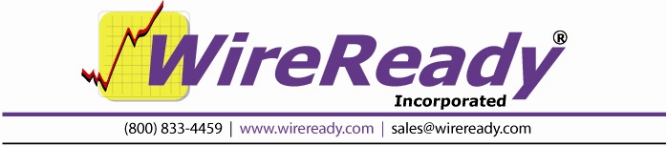

PlayoutReady Master Control

Users Guide

PlayoutReady Master Control

TABLE OF CONTENTS

INTRODUCTION 5
OVERVIEW 7
AUTOMATION DECKS & AUTOMATION PROGRAMS - WHAT ARE THEY? 7
WHAT ARE AUTOMATION DECKS? 7
WHAT ARE AUTOMATION PROGRAMS? 7
AUTOMATION DECKS & AUTOMATION PROGRAMS - THEIR RELATIONSHIP 8
SCREEN OVERVIEW: AUTOMATION DECK 9
TOP STATUS LINE 9
SEQUENCE LINES 10
OPTION BUTTONS 11
MAIN DROP-DOWN MENU 12
WORKING WITH AUTOMATION DECKS AND PROGRAMS 15
HOW TO GET TO THE AUTOMATION DECKS 15
HOW TO MOVE BETWEEN AUTOMATION DECKS 16
HOW TO CREATE AN AUTOMATION PROGRAM 17
HOW TO SAVE AN AUTOMATION PROGRAM 17
HOW TO LOAD AN AUTOMATION PROGRAM 17
HOW TO START AN AUTOMATION PROGRAM 18
HOW TO STOP AN AUTOMATION PROGRAM 18
HOW TO CHANGE A SAVED AUTOMATION PROGRAM 19
HOW TO CLEAR AN AUTOMATION DECK 21
COMMANDS 22
WHY TO USE PASTE TO COPY BLOCKS OF COMMANDS 22
HOW TO COPY BLOCKS OF COMMANDS IN THE SAME DECK 23
HOW TO COPY BLOCKS OF COMMANDS INTO ANOTHER DECK 24
HOW TO CROSS THE MIDNIGHT HOUR PROPERLY 25
INTRODUCTION TO COMMANDS 26
INTRODUCTION TO TIME WINDOWS 26
INTRODUCTION TO CHANNELS 27
COMMANDS SECTION 28
INTRODUCTION 28
COMTALK 29
HOW TO SET UP: ComTalk 30
CONFIRM AS RUN LOG 31
HOW TO SET UP: Confirm As Run Log 31
CONTROLDECK 32
HOW TO SET UP: Control Deck 32
CUSTOM 34
HOW TO SET UP: Custom 35
DELAY FOR 36
HOW TO SET UP: Delay For 36
FORCE INPUT CHANNEL 37
HOW TO SET UP: Force Input Channel 38
GET MEDIA 39
HOW TO SET UP: Get Media 40
GOTO 41
HOW TO SET UP: Goto 41
IF 42
HOW TO SET UP: If 43
IF DAY 44
HOW TO SET UP: If Day 44
IF MONTH 45
HOW TO SET UP: If Month 45
IF YEAR 47
HOW TO SET UP: If Year 47
LABEL 48
HOW TO SET UP: Label 48
LATCH CHANNEL 49
HOW TO SET UP: Latch Channel 49
LOAD AND START 50
HOW TO SET UP: Load and Start 51
PLAY VIDEO 52
HOW TO SET UP: Play Video 53
PLAY VIDEO LOW LEVEL 54
PULSE CHANNEL 55
HOW TO SET UP: Pulse Channel 56
RUN 57
HOW TO SET UP: Run 57
SCHEDULED BREAK 58
HOW TO SET UP: Scheduled Break 59
SET CLOCK 60
HOW TO SET UP: Set Clock 60
SET ENDTIME 61
HOW TO SET UP: Set EndTime 61
SKIP 62
HOW TO SET UP: Skip 62
STOP 63
HOW TO SET UP: Stop 63
TECH LOG 64
HOW TO SET UP: Tech Log 64
WAIT FOR CHANNEL 65
HOW TO SET UP: Wait for Channel 66
WAIT FOR HOT KEY 67
HOW TO SET UP: Wait for Hot Key 68
WAIT UNTIL 69
HOW TO SET UP: Wait Until 69
EXAMPLE OF AN AUTOMATION PROGRAM 70
SYSTEM CONFIGURATION AND OTHER OPTIONS 71
The Logs created by the Tech Log command 71
Working with Traffic Logs 72
The Format of the Log 72
Where the Traffic Log Needs to Be 74
How to Configure PlayoutReady Master Control to Work with Your Log 75
How to Set Up an Automation Program to Import the Traffic Log 77
How the Import Works 78
How to Import a Traffic/Music Log 79
Configuring PlayOutReady 81
The User *.ini File 81
Preventing Accidental Stopping of the Running Playlists 82
Locking the Automation Deck 82
Warning on Stop of Playlist and at Exit of Program 83
Printing the Playlists 84
Printing a List of Media Files from the MediaLog 85
HOW TO REACH WIREREADY 86

INTRODUCTION

PlayoutReady consists of two main pieces of software. PlayoutReady Master Control and PlayOutReady. PlayOutReady is a very simple program, consisting of a single EXE file and an INI file. The PlayOutReady exe file currently is small enough to fit on a floppy disk. The program can be setup by copying the EXE to a subdirectory on your hard-drive and making a shortcut on the desktop. Each instance of PlayoutReady is responsible for communicating with its configured mpeg2 decoder card and it queues and streams the the video out each card. PlayoutReady instances usually take all their commands from the Master Control software, however PlayoutReady can run stand-alone as a simple queue stacker and player. The Master Control Software will queue all consecutively stacked video files in any break/sequence over to the PlayoutReady instance so that once started even if you take the Master Control down or need to restart it for any reason, airplay can be maintained. Currently all media folders containing *.MPG files must be referenced with drive letters (or mapped drive letters). Future versions will allow UNC paths as well, so drive letters are not a requirement.

PlayoutReady Master Control is a powerful 32-bit automation system offering great flexibility. PlayoutReady Master Control, adapted from WireReady’s highly successful radio automation system, is responsible for master control scheduling, monitoring, switching and control triggering specific video files to play on the PlayOutReady system. PlayoutReady consists of 8 automation decks. Each automation deck runs scripts, i.e playlists consisting of both the video events you want to play and all logic that occurs including switching, routing, waiting for time and triggers and making anything else happen that you need. The decks work like schedulers and playlists can be built manually or generated from traffic logs or other imported text files. They allow for easy last minute editing by master control operators, even while running. They log every event and support quick copying and pasting of special event logs as well.

Both PlayOutReady and PlayOutReady Master Control need to run on Windows XP. Both programs are usually run from the same physical Windows XP machine playing content off the local hard-drive or storage array. Network/NAS drives can also be used to hold media that is played. It is also possible to split the programs and run Master Control on one machine and PlayoutReady on separate machines so long as they can see the same content via the same paths via shared drive/NAS connection. They communicate control commands with each other via tcp/ip. Additional users can also run the Master Control software from their own LAN connected PCs to access media files, ingest (index) new MPG files into the library and to maintain and admin the playlists and metadata.

Each running deck can control a single mpeg2 decoder card. So if running two stations from one PC, you would have two decks in operation with two instances of the PlayoutReady program running with 2 mpeg decoder cards. The affordability and licensing flexibility of PlayoutReady also makes it easy for stations to have multiple machines, each running one station per box just as easily.
PlayoutReady works exclusively with STRADIS based mpeg decoder cards, from the SDM230, 260, 280, 290, and 500 series on up. We also support Sky Micro Merlin05 and IP based encoder cards for real time recording/ingest functions. Merlin cards are used when a station needs to schedule automated recording from satellite or other sources that arrive in either SD, SDI or HD-SDI formats. While the Merlin cards can encode both mpeg2 and dv formats, we currently only play mpeg2 formats.

Because both platforms are file based- you can mix any 3rd party solutions with our products. You can use our Playout solution with other recording/encoding products or you can use our encoding product with other playout providers.

We use customer configurable GPI and RS232/422 command sets so we can be programmed to talk to a variety of switcher/routers. If they take GPI or you know the serial strings used to make them do things, we can control them. We can also receive and listen for GPI or RS-232 commands to tell us to do things as well.
We have a powerful “Playlist Builder” module which lets us decipher and read any ASCII text schedule or traffic log. Using our MACRO system we can key on specially named events, or “macros” in any column of the report to allow us to figure out automation directives (switching, waiting for presets on switchers etc) without your traffic system having to literally give us those commands. For example we can build complete automation schedules with even the most basic ASC style logs used with older automation systems, as well as major traffic suppliers such as VCI without customization. You can also employ your own software or middleware apps and create your own text files which drive our automation. We also can be programmed to automatically look for and import these files and build YYYY MM DD based log file names which drive automation for any length of unattended time.

PlayoutReady can accept standard MPEG2 video files using mpeg or pcm based embedded audio streams from a wide variety of 3rd party NLE and other software programs and devices. MPG files are simply imported (indexed) by selecting one at a time or selecting an entire folder, and our software automatically creates I-frame indexes for frame accurate playback and segment playback (play from/to positions within marked files) Although it is possible to copy MPG files directly to a play location for playback without indexing or adding metadata, it is strongly required that you let our software index all files. Indexing also allows you to assign metadata including start and stop dates, descriptions, ISCII and other broadcast data.

OVERVIEW

AUTOMATION DECKS & AUTOMATION PROGRAMS - WHAT ARE THEY?

WHAT ARE AUTOMATION DECKS?

There are eight (8) Automation Decks which can be used for creating, maintaining, and running your Automation Programs.

Automation Decks always have an Automation Program loaded. When you clear an Automation Deck, a blank Automation Program (called New Playlist) is instantly loaded into the Automation Deck.

WHAT ARE AUTOMATION PROGRAMS?

Automation Programs are sequences of Automation Commands that are arranged in an Automation Deck and saved with a unique name as an Automation Program.

Basically, an Automation Program is a list of things to do. Just like any other list, the commands (things to do) in an Automation Programs are listed, and therefore executed, in sequential order. Automation Programs are also referred to as Playlists.

Automation Programs are lists of commands which each do something. That "something" might be to play a commercial or program (which is stored in the computer), start a CD player, wait for a channel to get a closure (the satellite network sending a tone down), etc. See the Commands section in this manual for usage of each command.

AUTOMATION DECKS & AUTOMATION PROGRAMS - THEIR RELATIONSHIP

Automation Decks are used for creating Automation Programs as well as running them.

An Automation Program can be run in ANY Automation Deck, regardless of which Automation Deck was used to create the Automation Program.

More than one Automation Deck can be running at one time. Actually ALL eight Automation Decks can have Automation Programs running at the same time.

Automation Decks can be active at the same time that you are creating/editing an Automation Program in a different Automation Deck. You can make a copy of an Automation Program (by saving it to a different name), and edit the copy while the original Automation Program remains unchanged.

Automation Program will become active when the Automation Program is inserted into an Automation Deck and the START (F3) key is pressed.

One Automation Program can activate another Automation Program, with the "Load and Start" command. The second Automation Program runs in the SAME Automation Deck that the calling Automation Program was running in.

SCREEN OVERVIEW: AUTOMATION DECK

This is an Automation Deck with a blank, unsaved Automation Program loaded into it.

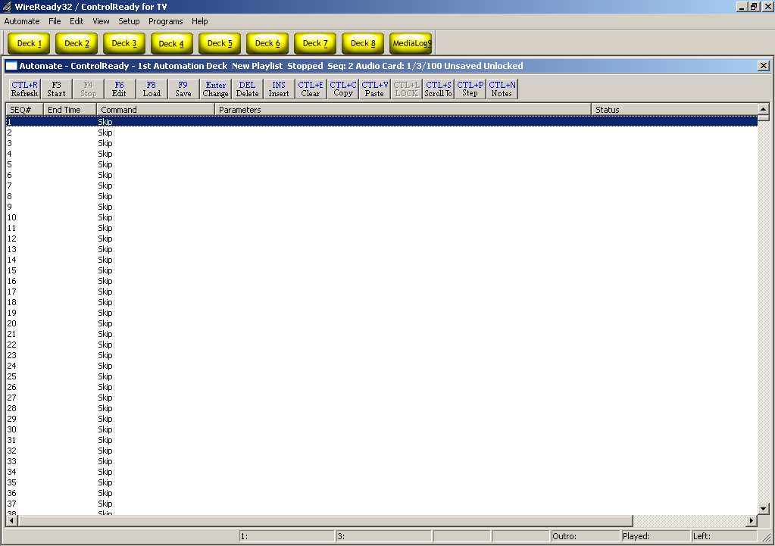

TOP STATUS LINE

The TOP STATUS LINE of the Automation Deck:
- Displays which Automation Deck you are in (1-8).
- Displays the name of the Automation Program that is currently loaded into this Automation Deck.
- Displays whether the Automation Deck is Running or Stopped.
- Displays the Sequence Number of the Automation Program where the Automation Program was last stopped. (When the Automation Program is running, this shows the sequence number of the line currently being executed).
- Displays whether the Automation Program has or has not been saved since modifications were last made to it.
- Displays whether the Automation Program is Locked or Unlocked.

SEQUENCE LINES

There are a total of 2400 sequences (1-2400) per Automation Program.

The SEQUENCE Line Displays:

- The Number of that sequence.
- The End Time of the media file, or the time that the file will be done playing.
- The Command that is on that sequence.
- The Command's Parameters (Parameters are details which are added to a command to customize it to do the specific task at hand).
- The Status of the command (waiting, playing, time remaining).

These fields’ widths can be changed if you put the mouse over the divider bar, then click and drag to change the field width or to hide the field.

OPTION BUTTONS
The OPTION BUTTONS at the top of the Automation Deck screen show the keys that can be used to perform operations within the Automation Deck. Each of the possible operations is explained within this manual.

Ctrl+R Refresh Refreshes the screen display.
F3 Start Starts the currently loaded playlist on the highlighted sequence #.
F4 Stop Stops the currently running playlist.
F6 Edit Allows the user to edit the command on the highlighted sequence #.
F8 Load Loads a previously saved playlist into the Automation Deck.
F9 Save Saves the currently loaded playlist.
Enter Change Changes the command on the highlighted sequence #.
DEL Delete Deletes the command and parameters from the highlighted sequence #. Will also remove the line, moving all following commands up one line.
INS Insert Inserts a Skip line above the highlighted sequence #. Will also move all following commands down one line.
Ctrl+E Clear Clears the loaded playlist and opens a blank New Playlist.
CTL+C Copy Copies the command in the highlighted sequence #.
CTL+V Paste Pastes single or multiple commands to the current playlist.
CTL+L Lock Toggles between Locked and Unlocked state.
CTL+S Scroll Allows the user to scroll to a specific sequence # in the playlist.
CTL+P Step Allows the user to run a command on one sequence of the playlist, where the playlist will not continue to the next line when the command is completed.
Ctrl+N Notes Opens a window to allow text notes about the deck. Information about when live periods are, which playlist should be running in the deck, which inputs and outputs are connected to each satellite receiver, or any other information that a user would need to know about this deck can be entered here.

MAIN DROP-DOWN MENU

The Main Menu, above the main Button bar, has 7 drop-down menus available for users to change decks, playlists, and screen viewing options. Use the keyboard shortcut or click on the choice with the mouse to activate the menu choice.

Automate
The Automate drop-down menu allows you to switch decks, start and stop the playlists, and switch to the MediaLog.
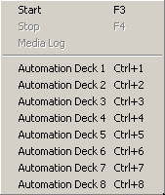
Start F3 Starts the currently loaded playlist on the highlighted sequence number.
Stop F4 Stops the currently running playlist.
MediaLog Used for media trace level logging. This will be grayed out, unless WireReady is using it for debugging purposes.
Ctrl+[1-8] Automation Deck 1-8 Allows the user to switch between decks

File
Open/Load Ctrl+O Loads a previously saved playlist into the Automation Deck.
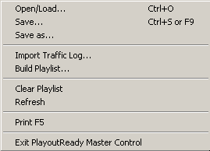
Save Ctrl+S or F9 Saves the currently loaded playlist.
Save as Saves the currently loaded playlist.
Import Traffic Log Starts the process of importing the Traffic log. See the section How to Import A Traffic Log in this manual for instructions.
Build Playlist
Clear Playlist Clears the loaded playlist and opens a blank New Playlist.
Refresh Refreshes the screen display.
Print F5 Prints the current playlist commands. See the section Printing the Playlists in this manual for instructions.
Exit PlayoutReady Master Control/TV Exits the program

Edit
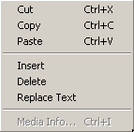
Cut Ctrl+X Deletes the command and parameters from the highlighted sequence #. Will also remove the line, moving all following commands up one line.
Copy CTL+C Copies the command in the highlighted sequence #.
Paste CTL+V Pastes single or multiple commands to the current playlist.
Insert Inserts a Skip line above the highlighted sequence #. Will also move all following commands down one line.
Delete Deletes the command and parameters from the highlighted sequence #. Will also remove the line, moving all following commands up one line.
Replace Text Opens a window that allows the user to replace text in certain commands in the playlist. See the section Replacing Text in a Playlist in this manual.

MediaLog Info Ctrl+I

View
The menu choices in this drop-down window are either checked or unchecked. The default is unchecked.

Hide Audio Paths and Extensions Removes the display of path and extension for the video files in the Play commands, when checked.
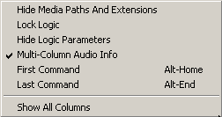
Lock Logic Sets the deck to only allow changes to or addition/deletion of Get Media, Play Video and Skip commands. All other commands are locked and cannot be edited or removed. Specific to the PlayoutReady Master Control deck. Can be set with a password.
Hide Logic Parameters Removes the display of parameters for most commands when checked. Does not affect the display of the Play, Get Media or Scheduled Break commands.
Multi-Column Audio Info When checked, the parameters of the Play commands are separated into multiple columns (Description, Artist, Length, etc). When unchecked, all parameters are displayed in the Parameters field of the playlist.
First Command Alt+Home Moves the cursor to the first sequence line that has a non-skip command on it.
Last Command Alt+End Moves the cursor to the last sequence line that has a non-Skip command on it.
Show All Columns Displays a portion of each column. The user will need to set the width for each column they wish to display.

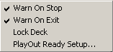
Setup
Warn on Stop Will pop up a warning window when F4 Stop is activated, when checked. Specific to the deck. Can be password protected.
Warn on Exit Will pop up a warning window when the program is exited, if the any of the decks are currently running. Can be password protected.
Lock Deck Controls whether the deck can be started, stopped, loaded or saved. Can be password protected.
PlayOutReady Setup Opens the window to configure the Playout Destination IP addresses and Ports.

Programs
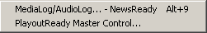
MediaLog/AudioLog – NewsReady Alt+9 The MediaLog is used to store video files to be used in automation.
PlayoutReady Master Control Launches the PlayoutReady Master Control Deck Selector window to navigate between decks.

WORKING WITH AUTOMATION DECKS AND PROGRAMS

HOW TO GET TO THE AUTOMATION DECKS

From the MAIN button bar, click on the yellow Deck# button, strike Alt+# or Ctrl+# for the number of the deck you wish to switch to.

To see a list of all the decks, click on Programs from the Main Menu, and then click on PlayoutReady Master Control.

The PlayOutReady Master Control - DECK SELECTOR screen will open:

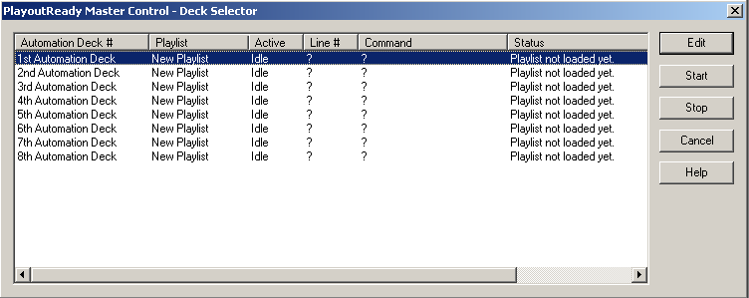
Note: The Deck Selector screen shows the Status of each of the Automation Decks. If a deck shows Idle, there is no playlist running on that deck. If the Status shows Active, that deck is currently running the listed playlist.

Highlight the Automation Deck that you want to go to and press Enter.
-OR-
Highlight the Automation Deck you want to go to and click on the Edit button.
-OR-
Double-click on the Automation Deck

HOW TO MOVE BETWEEN AUTOMATION DECKS
3 Methods

1). Using the Main Menu to open the list of 8 decks.
To see a list of all the decks, click on the Programs from the Main Menu, and then click on PlayoutReady Master Control.

The PlayOutReady Master Control - DECK SELECTOR screen will open:

Highlight the Automation Deck that you want to go to and press Enter.
-OR-
Highlight the Automation Deck you want to go to and click on the Edit button.
-OR-
Double-click on the Automation Deck

2). Using the drop-down menu choices.
From the main menu in WireReady32, click on Automate or strike Alt-A on the keyboard.
The drop-down menu will appear:
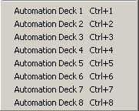
Click on the deck to move to.

3). Using the keyboard shortcuts
On the keyboard, strike the Ctrl key and the number of the deck at the same time. Or, strike the Alt key and the number of the deck at the same time.

HOW TO CREATE AN AUTOMATION PROGRAM
(All of the available commands are described in the Commands section.)

To create an Automation Program:
1) Go to an Automation Deck that is not currently active and click the Ctrl+E Clear button to clear the deck.
2) Create the Automation Program by:
a) Pressing Enter on a line and adding the necessary command.
b) Pressing F6 over an existing command and Edit the parameters of the command.
c) Pressing the Insert key to add a SKIP command.
d) Pressing the Delete key to delete a command.
e) Clicking on the Copy and Paste buttons to COPY BLOCKS of commands.
3) When you are done putting all of the commands in, press F9 to Save the Automation Program.
Type in the NAME that you want to assign to this Automation Program. If the name is the same name as another Automation Program and you go through with the Save, the original Automation Program will be overwritten by the one you just created.
4) After the Automation Program is Saved, you can click on the Clear button to Clear the Automation Deck.

HOW TO SAVE AN AUTOMATION PROGRAM

1) Press F9 to Save the Automation Program.
2) In the File Name entry box, type the name that you want to assign to this Automation Program, and press Enter or click Save.
-OR-
If the NAME is already there, just press Enter or click Save.
3) If a file with the same name exists, you will be prompted to replace the file. If you are sure you want to overwrite the program (if you were editing that program and are saving the changes) choose Yes to replace the file. If you are not sure if you should replace the file, choose No and give the file a different name.

HOW TO LOAD AN AUTOMATION PROGRAM

1) Press F8 while in the Automation Deck which you want to Load an Automation Program into.
-OR-
Click on the F8 Load button.
2) Type the NAME of the Automation Program that you want to Load, and press Enter or click the Open button.
-OR-
Highlight the Automation Program that you want to Load and press Enter or click on the Open button.

HOW TO START AN AUTOMATION PROGRAM

Strike the F3 key while in the Automation Deck which has the Automation Program that you want to Start loaded into it.
-OR-
Click on the F3 Start button.

If the Automation Decks already have the Automation Programs you want to run loaded, you can start all decks from the Automate Deck Selector window.
- Click on the Programs from the Main Menu, and then click on Automate-PlayoutReady Master Control to open the Automate Deck Selector window.
-Highlight the Automation Deck that you would like to start.
-Click on the Start button or strike Alt-S.
-Continue highlighting and starting the Automation Programs.
-Click the Cancel button when done to close the Selector window.

Note: A warning message was added to alert users attempting to exit the program that the Automation is currently running on the machine. This will let users know that they are about to exit the program and stop the media playback or recording that is scheduled in the playlists. The Warn on Exit menu choice under Setup must be checked for the warning message to be given. The message reads:
WARNING - AUTOMATION IS RUNNING
If the system is playing or recording, you can take your station off the air or kill a program (if one is being recorded).
Make sure your automation programs are idle/waiting and you won’t interrupt any programming.
Are you really sure you want to exit WireReady32?
(Choose Cancel to double check your automation programs before exiting.)

HOW TO STOP AN AUTOMATION PROGRAM

Press F4 while in the Automation Deck which has the Automation Program that you want to Stop loaded into it.

If you want to stop all decks from running, this can be done from the Automate Deck Selector window.
- Click on the Programs from the Main Menu, and then click on Automate-PlayoutReady Master Control to open the Automate Deck Selector window.
-Highlight the Automation Deck that you would like to stop.
-Click on the Stop button or strike Alt-T.
-Continue highlighting and stopping the Automation Programs.
-Click the Cancel button when done.

Note: A warning message was added to alert users attempting to stop the program that the Automation is currently running on the machine. This will let users know that they are about to exit the program and stop the media playback or recording that is scheduled in the playlists. The Warn on Stop menu choice must be checked under Setup for the warning to be given, and is specific to each deck. The message reads:
WARNING!
You are about to stop this automation deck. Anything playing or recording (or doing anything else) will stop.
Are you sure you want to stop this deck?

HOW TO CHANGE A SAVED AUTOMATION PROGRAM
To change (edit) an Automation Program:

1) Go to an Automation Deck that is not currently active and click on Ctrl+E Clear to clear the Deck.
2) Press F8 to Load an Automation Program.
Type the NAME of the Automation Program that you want to Load, and press Enter or click the Open button.
-OR-
Highlight the Automation Program that you want to Load and press Enter or click on the Open button.
3) Change the Automation Program by:
a) Pressing Enter over an existing command and overwriting it with a different command.
b) Pressing F6 over an existing command and changing the parameters of the command.
c) Pressing the Insert key to add a SKIP command.
d) Pressing the Delete key to delete a command.
e) Clicking on the Copy and Paste buttons to COPY BLOCKS of commands.
4) When you are done putting all of the commands in, press F9 to Save the Automation Program.
Type in the NAME that you want to assign to this Automation Program. If the name is the same name as another Automation Program and you go through with the Save, the original Automation Program will be overwritten by the one you just created.
5) After the Automation Program is Saved, you can click on the Ctrl+E Clear button to Clear the Automation Deck.

HOW TO CLEAR AN AUTOMATION DECK

Click the Ctrl+E Clear button to Clear the Automation Deck you are currently using.

The Automation Program that is in the Automation Deck will be cleared and all of the sequences will have the SKIP command on them.

Note: If the Automation Program which you are clearing has not been Saved since changes were last made to it, the changes will be lost if you Clear the Automation Deck.

Clearing an Automation Deck does not delete the Automation Program from the hard drive (unless it was never saved).

To Delete an Automation program you must go out to DOS or to Windows Explorer and delete the file. The filename will be the name of the Automation Program plus the ".PLY" extension. For example, if the name of the Automation Program that you want to delete is TUESDAY, then the file you need to delete will be called TUESDAY.PLY.

The drive and directory where the files are stored is configurable. However, the Automation Program files will probably be in the W:\WIRE\USERS\PUBLIC\FILES directory.

COMMANDS

WHY TO USE PASTE TO COPY BLOCKS OF COMMANDS

Copying blocks of commands is a VERY useful tool that will most likely save you a lot of time creating and changing Automation Programs.

Let's say that you are doing satellite automation and the commands for one hour are the same for many, or all, of the other hours. The only differences would be the time that the TIME WINDOWS are set to, the time that SET CLOCK sets the time to, and of course the PLAY commands. But when you are creating Automation Programs you need not consider which specific PLAYS will take place, but rather where in the program they will occur.

So this is what you would do:

1) Put in the commands for one full hour.
2) Use the PASTE command with the option to INCREMENT HOUR checked, and copy the hour that you created.

-OR-

Let's say you are adding a commercial break to each hour of the AUTOMATION PROGRAM. Instead of going to each hour and putting the same 4 or 5 commands in, you would use PASTE.
This is what you would do:

1) Put in the commands for the commercial breaks for one of the hours.
2) Use the PASTE command (instructions on next page) and copy the block of commands that contains the new breaks. IF THE BLOCK OF COMMANDS INCLUDES TIME WINDOWS, CHECK THE INCREMENT HOUR OPTION.
3) Repeat step #2 each time you want the block of break commands copied again.

HOW TO COPY BLOCKS OF COMMANDS IN THE SAME DECK

1) Highlight the sequence number that you want the block of commands to be copied to. THE HIGHLIGHT BAR CANNOT BE WITHIN THE BLOCK OF COMMANDS THAT YOU WANT TO COPY.

2) Click on the Paste button or strike Ctrl-V on the keyboard.

This window will open:
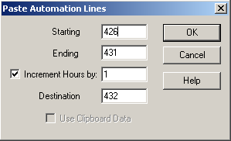

Uncheck Use Clipboard Data if it is checked.

3) Enter the sequence number of the first line of the block you want to copy in the Starting box
4) Enter the sequence number of the last line of the block you want to copy in the Ending box.
5) Check the Increment Hours by: box and enter in the number of hours to increment the time commands by.
6) Enter the sequence number of the line where the block is to be copied to in the Destination box.
7) Click the OK button.
When you use the Paste command with the INCREMENT HOUR option checked, ALL of the TIME WINDOWS are advanced by the number of hours entered in the box, and the THEN GOTO's for the TIME WINDOWS are changed to the correct sequence numbers.

HOW TO COPY BLOCKS OF COMMANDS INTO ANOTHER DECK
There may be times when you want to copy a block of commands from one playlist to another playlist in a different deck.

1) Highlight the first sequence number that you want to copy. While holding the Shift key down on the keyboard, click on the last command in the block that you want to copy.
2) Click on the Copy button or strike Ctrl+C on the keyboard. The block of commands will be sent to the clipboard.

3) Open the deck to paste the block of commands into and highlight the sequence number to paste the block to.

4) Click on the Paste button or strike Ctrl-V on the keyboard.

This window will open:
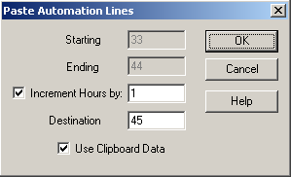

5) Check Use Clipboard Data. The Starting and Ending entry boxes will be grayed out.
6) Check the Increment Hours by: box and enter in the number of hours to increment the time commands by, if you will be incrementing the times in the commands that were copied.
7) Enter the sequence number of the line where the block is to be copied to in the Destination box. If you highlighted that sequence number above, this will be displayed.
8) Click the OK button or strike Enter to paste the block of commands.

When you use the Paste command with the INCREMENT HOUR option checked, ALL of the TIME WINDOWS are advanced by the number of hours entered in the box. Because of all of the variables involved in copying and pasting between decks, the sequence numbers in the THEN GOTO's for the TIME WINDOWS will probably not be accurate. Be sure to check the commands after they are pasted.

HOW TO CROSS THE MIDNIGHT HOUR PROPERLY

As of this writing you need to cross midnight differently than all of the other hours.

If the last command executed before midnight is to PLAY your legal ID, the Automation Program will stay on the PLAY command until the media is done and then move on to the next command. So there is a chance that the Automation Program will get to a command with a time window or a Wait Until command before midnight strikes. And what will happen when the Automation Program comes to that command?

Well, In terms of the time window, PlayoutReady Master Control will check the IF AFTER time which will be 00:xx:xx (because midnight is the 00 hour), and compare it to the current computer time. This command is gotten to before midnight, so when the times are compared, it will certainly be after 00 hour because it's the 23 hour (11 o'clock pm). And because the time is after the IF AFTER time, the THEN GOTO will be performed, and that is NOT what you want.

In terms of the WAIT UNTIL (00:xx:xx) command, the same thing will happen. When the command is reached, PlayoutReady Master Control will compare the time to WAIT UNTIL to the current computer time. This command is gotten to before midnight so when the times are compared, it will certainly be AFTER 00 hour because it's the 23 hour (11 o'clock pm). And because the time is after the WAIT UNTIL time, the Automation Program will proceed - and that is NOT what you want.

HOW TO FIX THE PROBLEM:

Use the IF command. When the IF command is used to look for a time before 1 am, it will wait until after the midnight hour is crossed before moving to the next command. An example of how the command can be used to cross midnight is below:

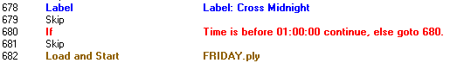

The Automation Program will look at the IF line, and compare the time to the computer's current time. If the time is before midnight, then it will be after 1 am, and the Automation Program will go to line 680. This is the same line that the IF command is on, so the Automation Program will continue to compare the time in the IF command with the computer's time. When the computer's time crosses midnight, the time will be before 1 am, and the Automation Program will continue to the next sequence. In the above example, the next line that the Automation will take action on is the Load and Start line, which will load and start the Friday playlist.

INTRODUCTION TO COMMANDS

INTRODUCTION TO TIME WINDOWS

A TIME WINDOWS is a block of time that you specify for a certain event (closure, hot key pressed, etc.) to take place. TIME WINDOWS consist of NOT BEFORE, IF AFTER, and THEN GOTO parameters.

- If the event occurs before the NOT BEFORE time, it will be ignored
- If the IF AFTER time is reached BEFORE the event occurs, the program will jump to the sequence number specified in THEN GOTO.
- If the event does, in fact, occur within the time window, the Automation Program will simply go to the next sequence number.

For example, let's say I am using the WAIT FOR CHANNEL B1-A to go HI command, which will cause the Automation Program to remain on the sequence which that command is on until the channel goes HI. And let's say that the channel will go HI when the satellite network sends down a tone to go to commercials. Now, what happens if someone at the network accidentally sends down the tone too early, or if they forget to send the tone altogether.

IF I AM NOT USING A TIME WINDOW:

If they send the tone too early, the Automation Program will cut off the media from the network and go into commercial.

If they forget to send the tone, the Automation Program will just sit on that sequence until someone corrects the situation.

IF I AM USING A TIME WINDOW:

If they send the tone before the NOT BEFORE time, the Automation Program will ignore it because it was probably a mistake or you do not want to cover that commercial break.

If they forget to send the tone, when the IF AFTER time is reached, the Automation Program will jump to the sequence specified in THEN GOTO.

IN SUMMARY, think of a time window as a plan that you might make with a friend. "I (the tone) will be not be there until :00, so if someone rings your doorbell do not open the door because it is not me (NOT BEFORE). If I am not there by 4:00, I am not going to make it and even if I do it is too late by then (IF AFTER), so go ahead and make your other plans (THEN GOTO)".

INTRODUCTION TO CHANNELS

There are two (2) types of channels, INPUTS and OUTPUTS.
INPUTS are channels that PlayoutReady Master Control monitors to be told what to do.
OUTPUTS are channels that PlayoutReady Master Control uses to tell a device to do something.

THINK OF INPUTS AS THE COMPUTER'S EARS.
THINK OF OUTPUTS AS THE COMPUTER'S MOUTH.

Each channel has a name (B1-A, etc.) so that PlayoutReady Master Control knows which channel to listen to, or talk to.

If you did not install the hardware for this system, ask the person who did to give you a COMPLETE list of what each of the channels are used for, as well as how they are to be used (latched, pulse, etc.).

IMPORTANT NOTE: WHEN PULSING, LATCHING, OR WAITING FOR A CHANNEL, HI IS EQUIVALENT TO CLOSED (CLOSURE) AND LO IS EQUIVALENT TO OPEN.

COMMANDS SECTION

INTRODUCTION
This COMMANDS section introduces you to each of the commands that are available to you for creating Automation Programs.

EACH command is presented to you with:
1) An EXAMPLE of the how the command looks when it is in an Automation Program.
2) The PURPOSE of the command.
3) An EXAMPLE OF USE of the command. These are only examples - there are a number of different possible uses for each command.
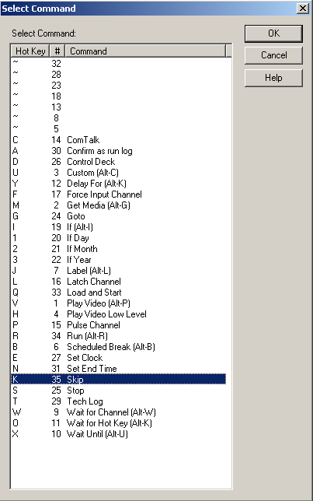
4) The PARAMETERS associated with each command. Parameters are details that are added to a command to customize it to do the specific task at hand.
5) IMPORTANT NOTES that you should know before using the command.
6) OTHER COMMANDS TO SEE which are similar in purpose, or associated with the command being presented.
7) STEP-BY-STEP INSTRUCTIONS FOR ADDING the command to an Automation Program.

The command list can be displayed in one of several ways when adding or editing a sequence line. The list of commands can be sorted by either Hot Key, #, or Command name by clicking on the header for the column.
Note: All time parameters are entered in the commands in Military Format (24 hour) using 6 digits as either HHMMSS or HH:MM:SS, where HH is hours, MM is minutes, and SS is seconds.
COMMANDS

COMTALK
ALL ABOUT: COMTALK

PURPOSE: The ComTalk command is used to send characters out a serial port (com port) to communicate with various devices using serial commands. This command is used mostly for communicating with audio switchers, but can also be used to communicate with the Broadcast Tools Watchdog, SCC4, SCC8, modems, and other devices.

EXAMPLE OF USE: If you wanted to tell the SCC4/SCC8 to select a channel on your satellite receiver, you would use the ComTalk command.

PARAMETERS: You type in the string of characters to send out the serial port.
You select the serial port that the device is connected to.
You select baud rate, parity, data bits, stop bits, and the inter-character delay that the device uses.

IMPORTANT NOTES: ComTalk is a ONE-WAY command. That means that we send characters out of the serial port, but will ignore ALL incoming characters returned from the device. Therefore devices that require data flow in both directions probably will not work well with this command. See the instruction manual for your specific hardware for details on the string to be used in the ComTalk command.

HOW TO SET UP: ComTalk
1) Highlight the sequence that you want the ComTalk command to go on.
2) Press Enter to open up the LIST OF COMMANDS.
3) Press C or highlight Com Talk and press Enter.

This window will open:
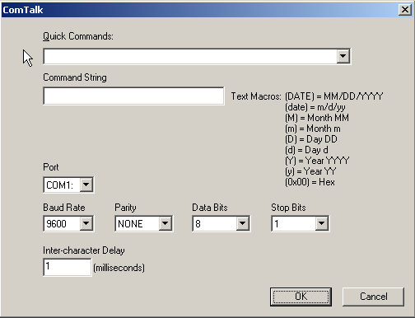

4) Enter the string of characters* that will be sent out of the specified serial port in the Command String box. * - If the string of commands that you need to send includes a CR (Carriage Return - ASCII 13), you need to use "{0x0d}" to reproduce the carriage return. Use the listed Text Macros within the string if needed.
5) Enter the serial (COM) port that the device you will be communicating with is connected to in the Port box.
6) Use the drop-down menu to select the Baud Rate that the device you are communicating with uses.
7) Use the drop-down menu to select the Parity that the device you are communicating with uses.
8) Use the drop-down menu to select the Data Bits that the device you are communicating with uses.
9) Use the drop-down menu to select the Stop Bits that the device you are communicating with uses.
10) Enter the inter-character delay that the device you are communicating with uses in the Inter-character Delay box. Unless your device requires a pause between characters, leave the intercharacter delay set to 1.
11) Click the OK button to save the parameters and add the command.

CONFIRM AS RUN LOG
ALL ABOUT: CONFIRM AS RUN LOG

PURPOSE: The Confirm command is used to turn on or off the confirmation log, which records the time that media played from a playlist.

EXAMPLE OF USE: This command is used to keep a log of what played and when it played.

PARAMETERS: You set the log to be either enabled (on) or disabled (off).

HOW TO SET UP: Confirm As Run Log
1) Highlight the sequence that you want the Confirm command to go on.
2) Press Enter to open up the LIST OF COMMANDS.
3) Press A or highlight Confirm as run log and press Enter.

This window will open:
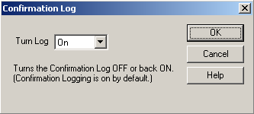

4) Use the drop-down menu to select either On or Off.
5) Click the OK button to save the parameters and add the command.

CONTROLDECK
ALL ABOUT: CONTROL DECK

PURPOSE: The Control Deck command is used to control another PlayoutReady Master Control deck.

EXAMPLE OF USE: This command could be used to control a deck during a remote event or ball game.

PARAMETERS: You set the PlayoutReady Master Control deck to control, if the other deck will be stopped or started, and the sequence line to start the other deck on.

HOW TO SET UP: Control Deck
1) Highlight the sequence that you want the Control Deck command to go on.
2) Press Enter to open up the LIST OF COMMANDS.
3) Press D or highlight Control Deck and press Enter.

This window will open:

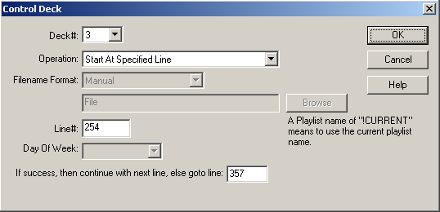

4) Use the drop-down list in the Deck# box to choose which deck to control.
5) Use the drop-down list In the Operation box to choose what action will be taken on the other deck.
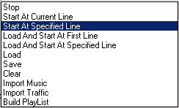
6) If one of the Load and Start statements is selected, the Playlist Format field will become active. If one of the statements to start at a Specified Line is selected, the Line# field will be active. If Import Music or Import Traffic is selected, the Day of Week field will be active.
7) Enter the playlist name, sequence line # to start on, or day of the week to import to.
8) Enter the sequence line number to go to if the command cannot be successfully executed.
9) Click the OK button to save the parameters and add the command.

CUSTOM
ALL ABOUT: CUSTOM

PURPOSE: The Custom command is used to save the parameters for frequently used commands in the Automation Program. By setting up a custom command, you can create a command that is easier to understand for the general user.

EXAMPLE OF USE: When switching between the computer's audio card and a network feed, it is easier to use a custom command to retain the correct Com Talk commands being sent to the switcher.

PARAMETERS: You set all of the parameters for the specific commands you want to create.

IMPORTANT NOTE: The Custom command is not a command that creates a specific result in the Automation Program. The Custom command has to be set up to use one of the existing commands, and will save the parameters for that command as one of the available custom commands.

HOW TO SET UP: Custom
1) Highlight the sequence that you want the Custom command to go on.
2) Press Enter to open up the LIST OF COMMANDS.
3) Press Alt-J, or highlight J-Custom and press Enter.

This selector box will open:
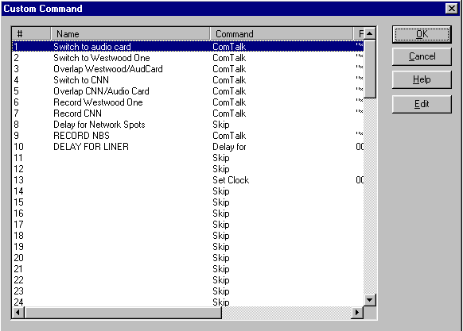

4) If there are already custom commands created, choose one of the commands and click the OK button to save the parameters and add the command.

To create a new Custom command:
1) Highlight an unused line to add the new custom command on.
2) Click the Edit button.
3) Enter a name for the custom command. This is the name that will appear in the Automation Program. Click the OK button
4) Highlight a command from the list and click the OK button.
5) Enter the parameters for the command you are creating. If you are unsure how to enter the parameters, refer to that command’s information in the Commands section of this manual.
6) When you are done creating the custom command, it will be added to the list of custom commands.
7) Continue adding new commands as needed. When done adding new commands, click the OK button.

DELAY FOR
ALL ABOUT: DELAY FOR

PURPOSE: The Delay For command is used to hold the program at a specific sequence number for a specified period of time.

EXAMPLE OF USE:

PARAMETERS: You set the time period to delay for.

ALSO SEE: WAIT UNTIL

HOW TO SET UP: Delay For
1) Highlight the sequence that you want the Delay For command to go on.
2) Press Enter to open up the LIST OF COMMANDS.
3) Press Y, or highlight Delay For and press Enter.

This window will open:
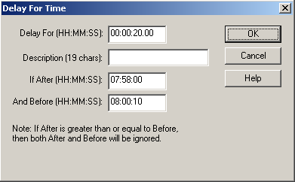
Note: Enter time parameters in Military Format (24 hour) using 6 digits as HH:MM:SS, where HH is hours, MM is minutes, and SS is seconds.

4) Enter the number of hours, minutes and seconds that you want the Automation Program to delay for in the Delay For box.
5) Enter a description into the Description field, if desired.
5) Enter the parameters to restrict this to a specific time of day in the If After and And Before entry boxes. There may be times that you would like to have the program delay if one event is shorter than desired, but not delay if it ends on time.
6) Click the OK button to save the parameters and add the command.

FORCE INPUT CHANNEL
ALL ABOUT: FORCE INPUT CHANNEL

PURPOSE: The Force Input Channel command is used when you do not have a device to detect a closure, but want to have active all automation decks act as if a closure was received.

EXAMPLE OF USE: You are airing a video file from one automation deck. When that video is finished playing, another automation deck needs to begin recording. The automation deck airing the video would, for example, have the command "Force Channel B1-A to have the value of HI", immediately after the play video command. The automation deck that will record would have the command "Wait for Channel B1-A to go Hi", immediately followed by the record command. This enables one automation deck to communicate with the other. NOTE: after the recording, you will probably want to have the recording automation deck issue the command "Force Channel B1-A to have the value of LO", so that you can later use the same method to trigger other recordings.

PARAMETERS: You set the channel alias to either be HI or LO.

IMPORTANT NOTES: Once you set a channel to be HI, you will want to have a command to set it LO, so the next command looking for that channel is not activated until the channel is HI again.

ALSO SEE: PULSE CHANNEL; LATCH CHANNEL

HOW TO SET UP: Force Input Channel
1) Highlight the sequence that you want Force Input Channel command to go on.
2) Press Enter to open up the LIST OF COMMANDS.
3) Press F, or highlight Force Input Channel and press Enter.

This window will open:
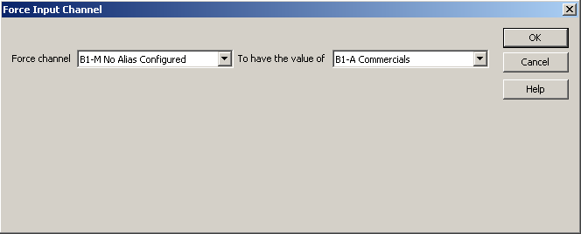

4) Use the drop-down menu in the Force Channel box to select the channel.
5) Use the drop-down menu in the To have the value of box to select whether you want to force the channel HI, LO, or to the value of another channel.
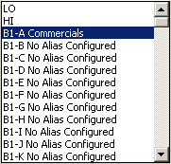
6) Click the OK button to save the parameters and add the command.

GET MEDIA
ALL ABOUT: GET MEDIA

PURPOSE: The Get Media command is used to tell PlayoutReady to locally cache the next break to its own hard drive. Doing this makes video playback respond more quickly.

EXAMPLE OF USE: You have a large file that may take a long time to play across the network. By using the Get Media command at a time when the Automation Program is not doing anything else, the file can be cached locally without affecting any other operation.

PARAMETERS: You set the command to Copy, Buffer, and Play.

HOW TO SET UP: Get Media
1) Highlight the sequence that you want the Get Media command to go on.
2) Press Enter to open up the LIST OF COMMANDS.
3) Press M, or highlight Get Media and press Enter.

This window will open:
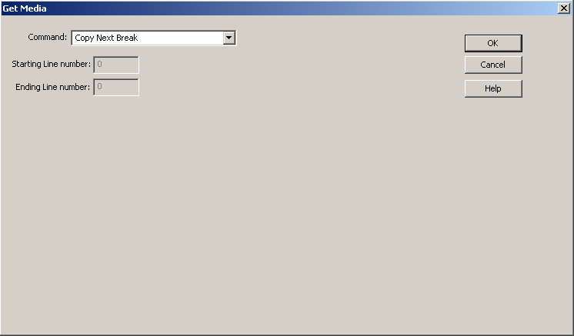

4) Use the drop-down menu in the Command box to select the
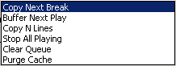
5) If you chose Buffer Next Play, the Starting Line number and Ending Line number fields become available to enter sequence line numbers.
6) Click the OK button to save the parameters and add the command.

GOTO
ALL ABOUT: GOTO

PURPOSE: The Goto command is used to make the program jump from the sequence the Goto command is issued on, to the sequence number specified.

EXAMPLE OF USE: If you want the program to repeat a certain set of commands, the last line of the set would be a Goto that specifies the first sequence number of the set of commands to repeat.

PARAMETERS: You select which sequence number you want the program to go to when it executes this command.

IMPORTANT NOTES: Goto is different than GoSub because Goto will cause the program to jump to a specific sequence number, without any memory of the sequence number that caused it to jump. While GoSub will cause the program to jump to a specific sequence number, and then return to the sequence below the GoSub.

ALSO SEE: GOSUB

HOW TO SET UP: Goto

1) Highlight the sequence that you want the Goto command to go on.
2) Press Enter to open up the LIST OF COMMANDS.
3) Press G, or highlight GOTO and press Enter.

This window will open:

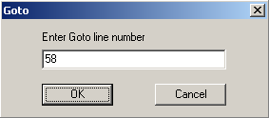

4) Type in the sequence number in the Enter Goto line number that you want the Automation Program to jump to when this command is executed.
5) Click the OK button to save the parameters and add the command.

IF
ALL ABOUT: IF

PURPOSE: The If command is used to check for either the current time, whether or not a closure has been received, or if a specified date has been met.

EXAMPLE OF USE (If Time…): For those music sweeps scheduled towards the end of an hour, an If Time command immediately before the scheduled music sweep command can determine whether to play those songs, or to skip ahead to legal ID, and the songs scheduled for the next hour.
PARAMETERS: You choose what time to check for, and which line to go to if it is after that time (or before that time).

EXAMPLE OF USE (If Channel): When a satellite network can send any of two or more closures to trigger jingle and liners, the If Channel command (in combination with If Time) can permit one playlist to check for all of the closures. This is done by have an If Time is before line, followed by If Channel is Lo for each of the possible closures.
PARAMETERS: You choose what channel to check for, which state (HI or LO) to check for, and which line to go to if it is NOT the state you are checking for.

EXAMPLE OF USE (If Date):
PARAMETERS:

HOW TO SET UP: If
1) Highlight the sequence that you want the If command to go on.
2) Press Enter to open up the LIST OF COMMANDS.
3) Press I, or highlight If and press Enter.

This selector box will open:
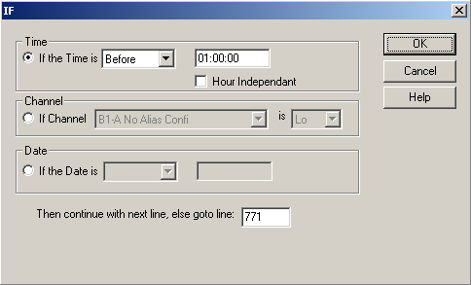
Note: All time parameters are entered in Military Format (24 hour) using 6 digits as HH:MM:SS, where HH is hours, MM is minutes, and SS is seconds.

4) a) If you are using time, use the drop-down menu to choose Before or After in the If the Time is box.
Enter the time of day the If command should use.
b) If you are using a channel, use the drop-down menu to choose the channel in the If Channel box.
Use the drop-down menu to choose if the channel should be Hi or Lo.
c) If you are using the date, use the drop-down menu to choose Before, On or After in the If the Date is box.
Enter the date to use in the second box in the Date section.
5) Enter the sequence number the Automation Program should go to in the Then continue with next line, else goto line: box.
6) Click on the OK button to save the parameters and add the command.

IF DAY
ALL ABOUT: IF DAY

PURPOSE: The If Day command is used when events occur on certain days of the week.

EXAMPLE OF USE:

PARAMETERS: You check the statements that reflect the days of the week that the playlist is to continue to the next line, and enter the sequence line number for the playlist to go to if the current day is not one of the selected days.

IMPORTANT NOTES:

ALSO SEE: IF MONTH; IF YEAR

HOW TO SET UP: If Day
1) Highlight the sequence that you want the If Day command to go on.
2) Press Enter to open up the LIST OF COMMANDS.
3) Press 1, or highlight If Day and press Enter.

This window will open:

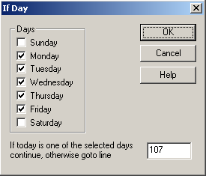

4) Click on the statements for the days of the week that the playlist is to continue to the next line.
5) Enter the line to go to if the day is not one of the selected days in the If today is one of the selected days continue, otherwise goto line entry box.
6) Press Enter or click on the OK button.

IF MONTH
ALL ABOUT: IF MONTH

PURPOSE: The If Month command is for ……..

EXAMPLE OF USE:

PARAMETERS: You check the statements that reflect the months of the year that the playlist should continue to the next line, and enter the sequence line number for the playlist to go to if the current day is not in one of the selected months.

IMPORTANT NOTES:

ALSO SEE: IF DAY; IF YEAR

HOW TO SET UP: If Month
1) Highlight the sequence that you want the If Month command to go on.
2) Press Enter to open up the LIST OF COMMANDS.
3) Press 2, or highlight If Month and press Enter.

This window will open:

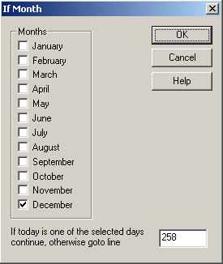

4) Check the statements for the months of the year in which the playlist should continue to the next line.
5) Enter the line to go to if the day is not within one of the selected months in the If today is one of the selected days continue, otherwise goto line entry box.
6) Press Enter or click on the OK button.

IF YEAR
ALL ABOUT: IF YEAR

Call WireReady technical support if you are looking to perform actions based on the year.

PARAMETERS: You check the statement that reflects the year that the playlist should continue to the next line, and enter the sequence line number for the playlist to go to if the current day is not within one of the selected years.
When you choose the year (this year, Next Year, etc), the sequence line will display the numeric equivalent (2004, 2005, etc)

ALSO SEE: IF DAY; IF MONTH

HOW TO SET UP: If Year
1) Highlight the sequence that you want the If Year command to go on.
2) Press Enter to open up the LIST OF COMMANDS.
3) Press 3, or highlight If Year and press Enter.

This window will open:

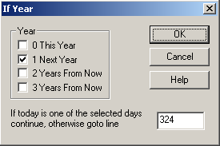

4) Choose the years in which the playlist should continue to the next line.
5) Enter the line to go to if the current day is not within one of the selected years in the If today is one of the selected days continue, otherwise goto line entry box.
6) Press Enter or click on the OK button.

LABEL
ALL ABOUT: LABEL

PURPOSE: The Label command is for you to put labels and comments into the Automation Program. PlayoutReady Master Control ignores all Label commands.

EXAMPLE OF USE: At the top of every program you should have Label commands that say the name of the Automation Program, as well as the purpose of the Automation Program, and what the different input and output channels are used for. Also at the top of every hour and before each break, as well as any other place you think it is a good idea to explain what the Automation Program is doing.

PARAMETERS: You type in the text to display on the sequence that the Label command is on.

ALSO SEE: SKIP

HOW TO SET UP: Label
1) Highlight the sequence that you want the Label command to go on.
2) Press Enter to open up the LIST OF COMMANDS.
3) Press J, or highlight Label and press Enter.

This window will open:

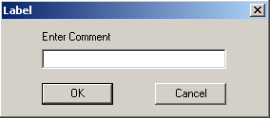

4) Type in the text that you want to be displayed, and press Enter or click on the OK button.

LATCH CHANNEL
ALL ABOUT: LATCH CHANNEL

PURPOSE: The Latch Channel command is used when you want an AT1616 output channel to go to a certain state (HI or LO) and remain in that state until another Automation Program or another device changes the state.

EXAMPLE OF USE: If you have a device that passes audio when it has a closure, you would latch a channel HI. When you do NOT want to allow audio to be passed through the device, you would latch the channel LO.

PARAMETERS: 1) You select the state (HI or LO) that you want to latch the channel.
2) You select which output channel you want latched.

IMPORTANT NOTES: Do NOT use the Latch Channel command unless the device that is connected to the channel that you are latching needs a constant closure/voltage. For Example, do NOT use the Latch Channel command when switching channels with the Broadcast Tools 6x1(a) Stereo Switcher, as that will make it so that you cannot change channels without first unlatching the channel which was latched.

ALSO SEE: PULSE CHANNEL; TURN NETWORK ON; TURN NETWORK OFF.

HOW TO SET UP: Latch Channel
1) Highlight the sequence that you want the Latch Channel command to go on.
2) Press Enter to open up the LIST OF COMMANDS.
3) Press L, or highlight Latch Channel and press Enter.

This window will open:
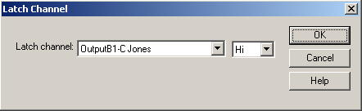

4) Use the drop-down menu in the Latch Channel box to select the output channel that you want to latch.
5) Use the drop-down menu to select whether you want to latch the channel HI or LO.
6) Click the OK button to save the parameters and add the command.

LOAD AND START
ALL ABOUT: LOAD AND START

PURPOSE: The Load and Start command is used to stop the Automation Program that is running and load and start a different program, on sequence 1, in the same automation deck.

EXAMPLE OF USE: If at the end of Monday's program you want to load the program for Tuesday, you would put a Load and Start command at the end of the Monday program so that when it reaches that point the Tuesday program is loaded into the same Automation Deck and immediately started on sequence 1.

PARAMETERS: You specify which Automation Program that you want to be loaded and started.

IMPORTANT NOTES: 1) Make sure that the Automation Program that you want to Load and Start exists.
2) This command will only have an effect on the Automation Deck in which it was executed. It will NOT have any effect on the other Automation Decks that are running.

ALSO SEE: STOP

HOW TO SET UP: Load and Start
1) Highlight the sequence that you want the Load and Start command to go on.
2) Press Enter to open up the LIST OF COMMANDS.
3) Press Q, or highlight Load and Start and press Enter.

This window will open:
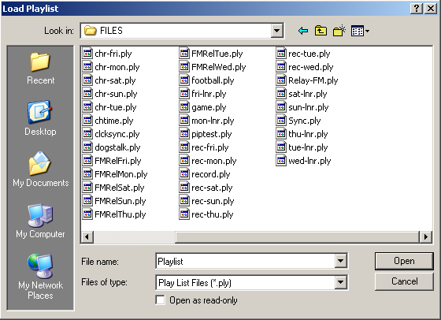

4) Highlight the Filename of the Automation program that you want to load and start when this command is executed and click the Open button.
-OR-
Double click on the Automation program that you want to load and start when this command is executed.

PLAY VIDEO
ALL ABOUT: PLAY VIDEO

PURPOSE: The Play Video command is used to play an AVI files.

EXAMPLE OF USE: When you want the Automation Program to play a program or commercial, you would use the Play Video command.

PARAMETERS: You select the AVI file you want to play and the folder it resides in.

IMPORTANT NOTE:

ALSO SEE: PLAY VIDEO LOW LEVEL

HOW TO SET UP: Play Video
1) Highlight the sequence that you want the Play Video command to go on.
2) Press Enter to open up the LIST OF COMMANDS.
3) Press V, highlight Play Video and press Enter, or double-click on Play Video.

This selector box will open:
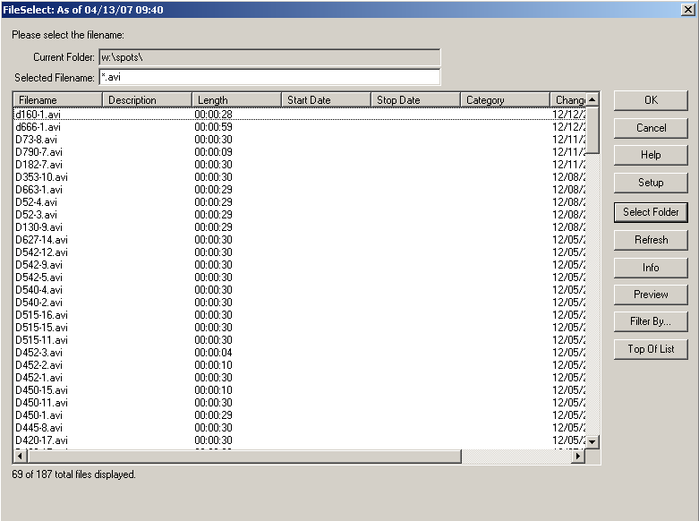

4) Choose an AVI file from the list, and double-click on it to select it.
-OR-
5) Click on the Select Folder button to choose a file from a different folder.
6) Choose the folder to switch to.
7) Choose an AVI file from the list, and double-click on it to select it.

PLAY VIDEO LOW LEVEL

This command is no longer used.

PULSE CHANNEL
ALL ABOUT: PULSE CHANNEL

PURPOSE: The Pulse Channel command is used when you want an output channel to go to a certain state for a specified number of milliseconds (1/1000 second) and then go to the opposite state than the state the Pulse Channel command caused.

EXAMPLE OF USE: If you want to switch channels on the Broadcast Tools 6x1(a) switcher, you would pulse the corresponding output channel on the AT1616 HI for 500 msecs. The channel on the AT1616 will make a closure for 500 msecs that will cause the 6x1(a) to switch channels. After 500 msecs, the AT1616 output channel will return to the open (non-closure) position - but the switcher will remain on the channel that it was switched to.

PARAMETERS: 1) You select which output channel you want to pulse.
2) You select whether you want the channel to be pulsed HI or LO.
3) You set the duration that you want the channel to be pulsed for.

IMPORTANT NOTES: Do NOT use the Pulse Channel command unless the device that you are controlling only needs a brief closure/voltage. The Pulse Channel command will be issued, then the program will continue to the next command. The program does not wait for the length of the pulse to continue, but pulses the channel and immedialtely continues.

ALSO SEE: LATCH CHANNEL

HOW TO SET UP: Pulse Channel
1) Highlight the sequence that you want the Pulse Channel command to go on.
2) Press Enter to open up the LIST OF COMMANDS.
3) Press P, or highlight Pulse Channel and press Enter.

This window will open:
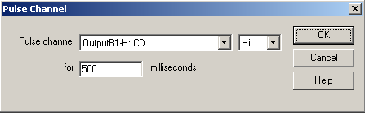

4) Use the drop-down menu to select the output channel that you want to pulse in the Pulse channel box.
5) Use the drop-down menu to select whether you want to pulse the channel Hi or Lo.
6) Enter the number of milliseconds that you want the channel pulsed for in the milliseconds box.
7) Click the OK button to save the parameters and add the command.

RUN
ALL ABOUT: RUN

PURPOSE: Run is used when you want a separate program to run outside of PlayoutReady Master Control at a certain point in the automation program.

EXAMPLE OF USE: The Run command can be used when you have recorded a program that you will be sending to other markets or affiliates, and it needs to be converted to a different format. A Run command can be scheduled for after the recording is completed, which would start the conversion program to run outside of the automation.

PARAMETERS: You enter the command string, including the path, file name and parameters to start the program.

IMPORTANT NOTE: You must include the path in the command string. This command was added to the program in version 4.006. The Run command is not displayed when using the Old Command Selection Dialog screen.

HOW TO SET UP: Run
1) Highlight the sequence that you want the Run command to go on.
2) Press Enter to open up the LIST OF COMMANDS.
3) Press R, or highlight Run and press Enter.

This selector box will open:
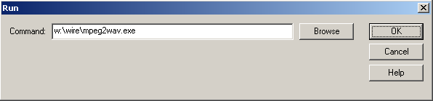

4) Enter the path and command string into the Command entry box.
5) Click the OK button to save the parameters and add the command.

SCHEDULED BREAK
ALL ABOUT: SCHEDULED BREAK

PURPOSE: Scheduled Break is used to schedule commercials and liners in the Automation Program. When using a traffic scheduling software, the breaks will be filled in according to the traffic schedule.

PARAMETERS: You choose the time that the break will occur. You choose the length of the break.

IMPORTANT NOTE: Scheduled Breaks can be added into the playlist where possible breaks may be. Not all breaks need to be filled in by the traffic software. This command is used as a marker for the scheduling software. The Automation Program, when running, treats this command like a Skip command--it simply goes to the next line.

ALSO SEE:

HOW TO SET UP: Scheduled Break
1) Highlight the sequence that you want the Scheduled Break command to go on.
2) Press Enter to open up the LIST OF COMMANDS.
3) Press B, highlight Scheduled Break and press Enter, or double-click on B-Scheduled Break.

This selector box will open:
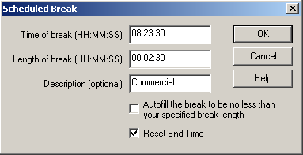
Note: All time parameters are entered in Military Format (24 hour) using 6 digits as HH:MM:SS, where HH is hours, MM is minutes, and SS is seconds.

4) Enter the time of day that the break should occur in the Time of break field.
5) Enter the length of time that the break should last in the Length of break field.
6) Enter a description of the break, if desired, in the Description box.
7) Check Fill the break exactly to have an audio file inserted at the end of the break if the traffic program does not have the break filled entirely. A rotation or audio file will need to be created for each amount of time that could be filled, (from 60 to 1 second) and placed in the “fill” folder.
8) Check Reset End Time to have the End Time reset to the time set in the Time of break field at the beginning of the break. The end time of the audio files will be based on this reset end time.
9) Click the OK button to save the parameters and add the command.

SET CLOCK
ALL ABOUT: SET CLOCK

PURPOSE: The Set Clock command will set the computer's clock to the time of day that is specified. It is very important to keep the computer's clock accurate.

EXAMPLE OF USE: If you know that your satellite network sends down a tone at exactly 59 minutes and 55 seconds after the hour (xx:59:55), you would put in a Wait for Channel or Wait for Closure command to catch the tone, and then the very next command would be Set Clock.

PARAMETERS: You select the hour, minute, and second that you want the computer's clock set to. You decide the maximum number of minutes that the clock is allowed to be changed.

IMPORTANT NOTES: You should only use Set Clock when you are sure an event (closure, etc.) will happen at an exact time.

HOW TO SET UP: Set Clock
1) Highlight the sequence that you want the Set Clock command to go on.
2) Press Enter to open up the LIST OF COMMANDS.
3) Press E, or highlight Set Clock and press Enter.

This window will open:
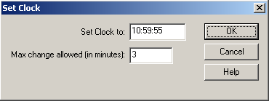
Note: All time parameters are entered in Military Format (24 hour) using 6 digits as HH:MM:SS, where HH is hours, MM is minutes, and SS is seconds.

4) Enter the time in the Set Clock to box.
5) Enter the maximum number of minutes that the clock is allowed to be changed in the Max change allowed (in minutes): entry box.
6) Click the OK button to save the parameters and add the command.

SET ENDTIME

ALL ABOUT: SET ENDTIME

PURPOSE: The Set EndTime command is used to reset the EndTime of the commands in a playlist. All following commands will calculate their EndTimes based on this command executing at the specified time. Sometimes only the deck programmer can know when the command will really execute. This is for those times.

EXAMPLE OF USE: When playing music from hard-drive, and doing live news, you can use the Set EndTime command to mark when the live news is done. This will allow the end time of the songs to reflect the actual times that each file will end playing.

PARAMETERS: You set the time that the event will be ending.

IMPORTANT NOTES: This command will affect the end time of all the commands following the Set EndTime command.

HOW TO SET UP: Set EndTime
1) Highlight the sequence that you want the Set EndTime command to go on.
2) Press Enter to open up the LIST OF COMMANDS.
3) Press N, or highlight Set End Time and press Enter.

This window will open:
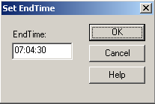
Note: All time parameters are entered in Military Format (24 hour) using 6 digits as HH:MM:SS, where HH is hours, MM is minutes, and SS is seconds.

4) Enter the time in the EndTime box.
5) Click the OK button to save the parameters and add the command.

SKIP
ALL ABOUT: SKIP

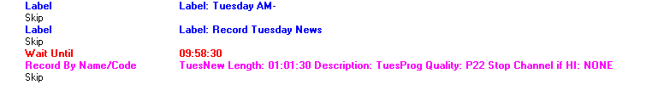

PURPOSE: The Skip command is just an optional space between commands to make the program easier to read/follow. PlayoutReady Master Control ignores all Skip commands.

EXAMPLE OF USE: Between scheduled breaks you would probably want a couple of skips to separate the breaks, as well as between different hours.

PARAMETERS: There are no parameters associated with this command

IMPORTANT NOTES: PlayoutReady Master Control ignores all Skip commands. All GOTO commands will be adjusted correctly as you insert Skips.

ALSO SEE: LABEL

HOW TO SET UP: Skip
1) Highlight the sequence that you want the Skip command to go on.
2) Press the Insert key on the keyboard.

-OR-

1) Highlight the sequence that you want the Skip command to go on.
2) Press Enter to open up the LIST OF COMMANDS.
3) Press K, or highlight Skip and press Enter.

STOP
ALL ABOUT: STOP

PURPOSE: The Stop command is used to stop the Automation Program when the command is executed.

EXAMPLE OF USE: If you want the Automation Program to shut down at 7:50 pm, you would put a Wait Until 19:50:00 command followed by Stop.

PARAMETERS: There are no parameters associated with this command.

IMPORTANT NOTES: This command will only stop the Automation Program that contains the Stop command. All other Automation Programs that are running will continue to run.

ALSO SEE: WAIT UNTIL; LOAD AND START

HOW TO SET UP: Stop
1) Highlight the sequence that you want the Stop command to go on.
2) Press Enter to open up the LIST OF COMMANDS.
3) Press S, or highlight Stop and press Enter.

TECH LOG
ALL ABOUT: TECH LOG

PURPOSE: The Tech Log command will cause a file to be created that will record the date and time that each line of the Automation Program was executed.

EXAMPLE OF USE: This is an information and trouble-shooting tool. It gives you the ability to go back at a later time and determine what media files played, when the automation switched to and from satellite networks, or any other commands that have been set up.

PARAMETERS: You choose to turn the logging on or off.

IMPORTANT NOTE: Logging is off by default, so if you do not put a Log On command in a playlist, none of its commands are logged.

IMPORTANT NOTE: If you are using a liner playlist, such as shown in the examples for the If and Goto commands, do NOT turn on logging for that playlist. The log file for such a playlist would become too large.

HOW TO SET UP: Tech Log
1) Highlight the sequence that you want the Tech Log command to go on.
2) Press Enter to open up the LIST OF COMMANDS.
3) Press T, highlight Tech Log and press Enter, or double-click on Tech Log.

This selector box will open:
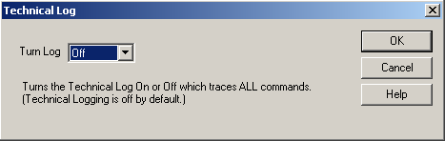
4) Use the drop-down menu to choose Off or On in the Turn Log box.
5) Click the OK button to add the command.

WAIT FOR CHANNEL
ALL ABOUT: WAIT FOR CHANNEL

PURPOSE: The Wait for Channel command is used to hold the Automation Program on a specific sequence number until the specified input channel makes a closure (or the voltage goes HI or LO), or the time window (if used) expires.

EXAMPLE OF USE: If you were waiting for a tone from your satellite network that will in turn create a closure on one of your input channels (or cause the voltage to go HI), you would issue this command. Then the Automation Program stays at this sequence until the input channel makes a closure (or the voltage goes HI or LO), or the time window (if used) expires, and then moves on to the next sequence.

PARAMETERS: 1) You select which input channel is to be monitored.
2) You select whether we are looking for the selected channel to go HI or LO.
3) You select whether or not the command will obey a time window.
4) If you choose to obey a time window, you set the time parameters, and the sequence to go to if the time window expires.

IMPORTANT NOTES: This command is used with the AT1616L Controller. See the AT1616 document for a diagram of which terminal numbers correspond with which channels.

ALSO SEE: WAIT FOR HOT KEY; WAIT UNTIL.

HOW TO SET UP: Wait for Channel
1) Highlight the sequence that you want the Wait for Channel command to go on.
2) Press Enter to open up the LIST OF COMMANDS.
3) Press W, or highlight Wait for Channel and press Enter.

This window will open:
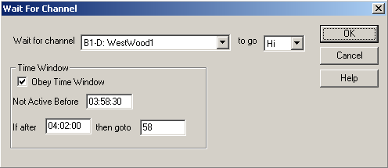
Note: All time parameters are entered in Military Format (24 hour) using 6 digits as HH:MM:SS, where HH is hours, MM is minutes, and SS is seconds.

4) Use the drop-down menu in the Wait for channel box to select the input channel to monitor.
5) Use the drop-down menu in the to go box to select whether the input channel which you specify will be monitored to go Hi (closure) or Lo (open).
6) If you have checked Obey Time Window:
- Enter the earliest time which you want this command to be executed in the Not Active Before box.
- Enter the latest time that you want this command to be executed in the If after box.
- Enter the sequence number that you want the Automation Program to jump to if the command does not occur by the If after time in the then goto box.
7) Click the OK button to save the parameters and add the command.

WAIT FOR HOT KEY
ALL ABOUT: WAIT FOR HOT KEY

PURPOSE: The Wait for hot key command is used to hold the Automation Program at a specific sequence number until ALT-F3 is pressed, or the time window expires.

EXAMPLE OF USE: If you go live for an unspecified period of time, you would issue the Wait for hot key command so that when you are ready to continue with the Automation Program all you have to do is press ALT-F3.

PARAMETERS: 1) You choose whether or not the command should obey a time window.
2) If you choose to obey a time window, you set the Not Active Before & Continue After times, and the Goto Line if the time window expires.

IMPORTANT NOTES: When ALT-F3 (the hot key) is pressed ALL Automation Programs that are on a Wait for hot key command will advance (except those with time windows that exclude them).

ALSO SEE: WAIT FOR CHANNEL; WAIT UNTIL; DELAY FOR.

HOW TO SET UP: Wait for Hot Key
1) Highlight the sequence that you want the Wait for Hot Key command to go on.
2) Press Enter to open up the LIST OF COMMANDS.
3) Press O, or highlight Wait For Hot Key and press Enter.

This window will open:
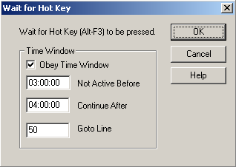
Note: All time parameters are entered in Military Format (24 hour) using 6 digits as HH:MM:SS, where HH is hours, MM is minutes, and SS is seconds.

4) If you have checked Obey Time Window:
- Enter the earliest time which you want this command to be executed in the Not Active Before box.
- Enter the latest time that you want this command to be executed in the Continue After box.
- Enter the sequence number that you want the Automation Program to jump to (if the command does not occur by the Continue After time) in the Goto Line box.
5) Click the OK button to save the parameters and add the command.

WAIT UNTIL
ALL ABOUT: WAIT UNTIL

PURPOSE: The Wait Until command is used to hold the Automation Program on a specific sequence number until a specified time of day.

EXAMPLE OF USE: If you want to switch to ABC News at 5:00 am, you would put a Wait Until 05:00:00 command. The commands following the Wait Until would be to select ABC (PULSE, LATCH, etc.).

PARAMETERS: You set the hour, minute, and second to wait until.

IMPORTANT NOTES: When the Automation Program comes across this command, it will stay on the sequence until the time of day is at, or after, the time specified.

ALSO SEE: DELAY FOR; WAIT FOR HOT KEY; WAIT FOR CHANNEL

HOW TO SET UP: Wait Until
1) Highlight the sequence that you want the Wait Until command to go on.
2) Press Enter to open up the LIST OF COMMANDS.
3) Press X, or highlight Wait Until and press Enter.

This window will open:
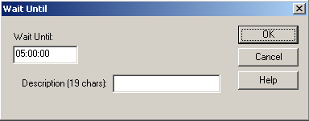
Note: All time parameters are entered in Military Format (24 hour) using 6 digits as HH:MM:SS, where HH is hours, MM is minutes, and SS is seconds.

4) Enter the HOUR, MINUTE, and SECOND that you want the program to Wait Until.
5) Enter a description of why it is waiting, if desired, in the Description box.
6) Click the OK button to save the parameters and add the command.

EXAMPLE OF AN AUTOMATION PROGRAM

These are an example of the beginning of an Automation Program.

WireReady has Automation Programs that were written for a number of satellite networks. These programs can be sent to you on disks or downloaded. Call a WireReady Technical Representative for more information.

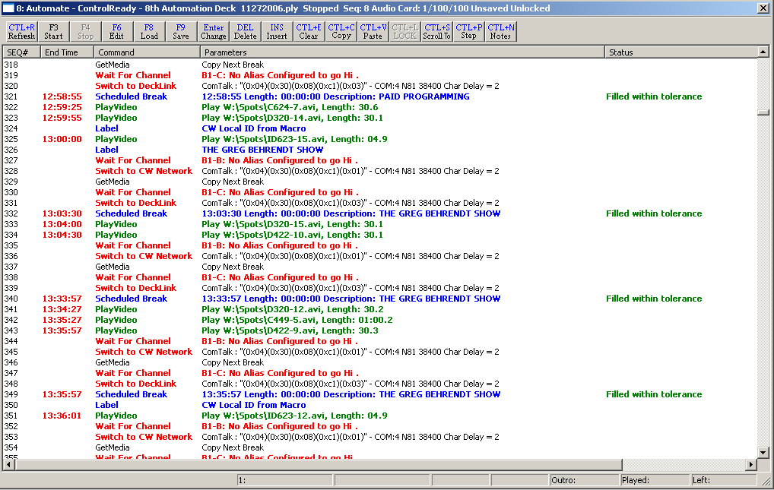

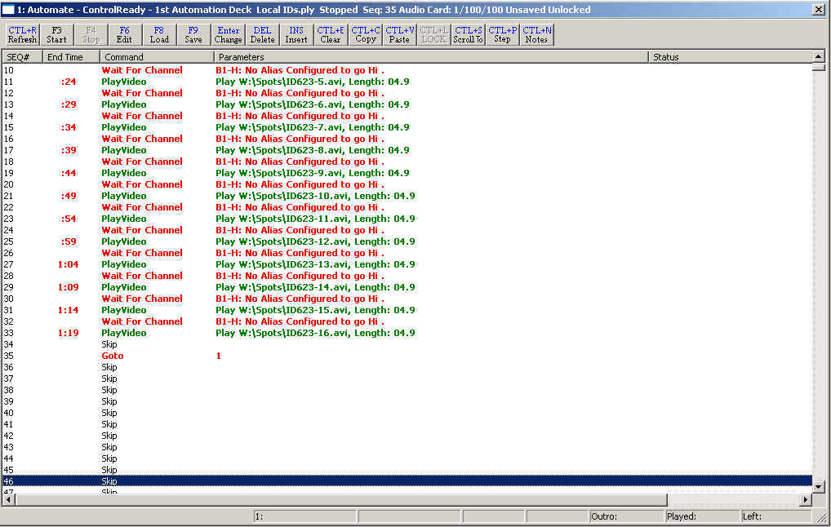

SYSTEM CONFIGURATION AND OTHER OPTIONS

The Logs created by the Tech Log command

The log file is written in the Log folder of the user’s directory. The filename consists of the deck number, the month, the day, the year, and the playlist’s name, all separated with underscores, followed by the extension “.log”.
For example, if the root directory is “W:\Wire”, the user’s name is “Testuser”, the automation deck is 1, the date is 2-3-2002, and the playlist’s name is “Monday”, then the name of the log file is “W:\Wire\Users\Testuser\Logs\1_2_3_2002_Monday_ply.log”.
The log file will be appended to, but neither deleted nor overwritten. It is the responsibility of the system administrator to delete unwanted logs.
The format of the log file is [sequence line number]-[time that the line was executed]-[total length of time the playlist has been running] [the command and its parameters].
Example of the log created by the Log command:
1-16:58:23- 0:01:08:17 Tech LogOn
1-16:58:23- 0:01:08:17 Logging being turned on.
2-16:58:23- 0:01:08:17 LabelPAID PROGRAM
3-16:58:23- 0:01:08:17 Wait For ChannelB1-B: No Alias Configured to go Hi .
3-16:58:33- 0:01:08:27 Channel 2 is 1
4-16:58:33- 0:01:08:27 Switch to CW NetworkComTalk : "(0x04)(0x30)(0x08)(0xc1)(0x01)" - COM:4 N81 38400 Char Delay = 2
4-16:58:33- 0:01:08:27 ComTalk"(0x04)(0x30)(0x08)(0xc1)(0x01)" - COM:4 N81 38400 Char Delay = 2
4-16:58:33- 0:01:08:27 ComTalk"(0x04)(0x30)(0x08)(0xc1)(0x01)" - COM:4 N81 38400 Char Delay = 2
5-16:58:33- 0:01:08:27 GetMediaCopy Next Break
9-16:58:34- 0:01:08:28 PlayVideoPlay W:\Spots\C450-12.avi, Length: 00
5-16:58:35- 0:01:08:29 GetMedia Finished.
6-16:58:35- 0:01:08:29 Wait For ChannelB1-C: No Alias Configured to go Hi .
6-16:58:37- 0:01:08:31 Channel 3 is 1
7-16:58:37- 0:01:08:31 Switch to DeckLinkComTalk : "(0x04)(0x30)(0x08)(0xc1)(0x03)" - COM:4 N81 38400 Char Delay = 2
7-16:58:37- 0:01:08:31 ComTalk"(0x04)(0x30)(0x08)(0xc1)(0x03)" - COM:4 N81 38400 Char Delay = 2
7-16:58:37- 0:01:08:31 ComTalk"(0x04)(0x30)(0x08)(0xc1)(0x03)" - COM:4 N81 38400 Char Delay = 2
9-16:58:37- 0:01:08:31 PlayVideoPlay W:\Spots\C450-12.avi, Length: 00
9-16:58:48- 0:01:08:42 Play of W:\Spots\C450-12.avi timed out. Aborting.
9-16:58:48- 0:01:08:42 Finished playing W:\Spots\C450-12.avi. Overlap with next command.
10-16:58:48- 0:01:08:42 LabelCW Local ID from Macro
11-16:58:48- 0:01:08:42 PlayVideoPlay W:\Spots\ID623-6.avi, Length: 00
11-16:58:59- 0:01:08:53 Play of W:\Spots\ID623-6.avi timed out. Aborting.
11-16:58:59- 0:01:08:53 Finished playing W:\Spots\ID623-6.avi. Overlap with next command.
12-16:58:59- 0:01:08:53 LabelPAID PROGRAM

Working with Traffic Logs

PlayoutReady Master Control allows you to automatically import traffic/billing scheduling logs from 3rd party systems. Rather than manually typing in the code of every video file you want to play, importing these logs builds a list that saves you hundreds and thousands of keystrokes.

Unlike other digital systems, our system lets you configure us to read ANY format. You do not have to pay for any special interfaces to make this work. Most log programs can "print" the log that normally comes off your printer to an ASCII/text file. Even if there is no specific key in the program to do this, we can generally show you how to make your log program print to a floppy disk/file even if it thinks it sending it to your printer.

As long as your logs show the video file/code/numbers in some kind of a column, and the air times in some kind of column, we can read it. The columns can be anywhere on the page, and the log can have all sorts of other columns, and information which we will automatically skip over.

The Format of the Log

PlayoutReady Master Control will work with all traffic logs that are in ASCII TEXT format.

Traffic software makes you create a unique name, number, or code for every video file you want to schedule. 99% of the systems out there force you to use numbers, from 1 to 8 digits. Some allow letters, spaces, or a combination of everything.

MediaLog and Automate will read numbers, spaces, and letters, or any combination there of, from 1 to 8 characters long. The trick is to save your video recordings in MediaLog/Automate with the exact name/code/number as the name/code/number you refer to in your scheduling system.

Thus if you have a file 500 in your traffic log, you must save the video file as 500 in MediaLog. If you have a file in your traffic log as 0500, it must be saved in MediaLog as 0500.

The Format:

Good news! There is no single format. We can work with anything so long as:
All file code/number/names appear in some kind of column through the log printout.
Airtimes also appear on the same line as the file code/number/names.
Note: An airtime doesn't have to appear with every single video file, but we recommend it.
Air Times can be military time: 15:24:00
or Civilian: 03:24:00 pm

Look at your PRINTED log. If your log shows your file number/name/codes, and airtimes, in some kind of columnar printout, you are halfway there.

The column can be anywhere on the page as long as it's consistent throughout the report.
For example:

------------------------Traffic Log ---------------------------------------------------

10:00:00 500 Burger Queen :30
10:00:30 750 Taco Prince :60
10:01:30 PSA3 Buckle Up :60

In the above example, the airtime is military, and 4 spaces from the left hand margin. (we call this the offset). The file names appear 22 spaces from the left hand margin.

These are the only two pieces of information we need to scan in the entire log. We ignore everything else and simply home in on these two columns to find video files and times.

When we import, there is a lot of flexibility. We will ignore any line that doesn't have a file code that corresponds to something recorded on your hard-drive.

Had the airtime been in civilian time, we would have also noted the number of characters from the left hand margin that the AM, PM, a or p, occurred.

Had only the first airtime been there, all three would have been scheduled in your 10:00 break as shown. We update the time when we see a different one, if we don't, we assume they all go together. Either way works.

Some logs right-justify codes in their column. This is okay since we will STRIP preceding spaces. We strip trailing spaces as well. We can also ignore format characters if they are surrounded by parenthesis, brackets etc.
Making your traffic system generate this kind of file:

If you are not sure whether your traffic log is, or can be, in ASCII TEXT format, check the documentation that came with the traffic software.

Changing the printer configuration of your traffic/music program:

Many log programs have a printer configuration screen that can redirect the printed output to a file. With systems like this, you would do the following:

Print your log as you would normally (if you still want hard-copy).
Go to the configuration screen.
Change the printer destination to file (if it asks for a file destination, we recommend printing it directly to a floppy disk, i.e. A:\traffic.log or A:\music.log).
Reprint the log, and the program will now send the log to the designated file.

Some traffic software lets you choose a printer every time you print. With these programs it's even easier since anytime you print a log, you can choose whether you are printing it to disk or the printer.

Where the Traffic Log Needs to Be

MediaLog and PlayoutReady Master Control need to know where to find the traffic log. You can specify where the log is from within the PlayoutReady Master Control program. Therefore, the drive, directory and filename of the traffic log to import are variable. The only issue is that the traffic log can be accessed from the PC that PlayoutReady Master Control is run on.

If the traffic log is on a PC which PlayoutReady Master Control does not have access to (i.e. the trafficking system is on a different PC than PlayoutReady Master Control, and the PC's are not on a LAN), then the traffic log will need to be put on a floppy disk and copied to a drive PlayoutReady Master Control can access.

If you have the traffic program saving the log with a name, this name must be known when you import it.

For example if you saved the traffic log to A:\TRAFFIC.LOG on a disk, when you bring the disk over to PlayoutReady Master Control, you will need to type A:\TRAFFIC.LOG when it asks you for the name and path of the log file.

If you are on a LAN, and all your computers are connected, and you save it to F:\traffic.log, you would import it as F:\traffic.log. It works the same, except you don't have to carry a disk.

How to Configure PlayoutReady Master Control to Work with Your Log

Your traffic log contains a lot of useful information, but the only thing that PlayoutReady Master Control wants to know is "what are the video file codes/names/numbers?"

In order for us to find the video file codes you need to specify two parameters:

Offset--The number of characters from the left that the video file code begins.
Length--The max number of characters long of the video file codes in the traffic log.

For example, you need to tell PlayoutReady Master Control that within the traffic log the first character of the video file code is 15 characters from the left and the length of the video file codes is 5.

How do you know what the two numbers, the offset and the length, are? The best way is to use the DOS "EDIT" command. When you bring your log up with the "EDIT" command, you can see what the Offset is by positioning the cursor under the first character of the video file code and seeing what number is displayed on the far right of the last line on the screen.
That is the Offset. The Length is the maximum length the video file code can be in the trafficking log. This may be set by the trafficking software and cannot exceed eight (8) characters.

To Set These Parameters in PlayoutReady Master Control:
These settings can be changed manually, or the Setup32 utility program can be used to configure the log import settings. See the Manual For The Setup32 Utility document for instructions on configuring the PlayoutReady Master Control settings.

The Log Import settings are stored in the user's *.ini file. The path to locate this file is "[server letter]:\wire\users\[user name]\[user name].ini"
(i.e. w:\wire\users\onair1\onair1.ini). Use Windows Explorer or DOS to locate and open the ini file for editing.

The Automation section contains the settings that will need to be configured to import logs. Below is the Automation section of an ini file, with the lines that are used for importing logs. Check the section, The User *.ini File, for a complete list of settings in the ini files.

ImportTrafficWave FileOffset=15 The number of characters from the left that the video file code begins.
ImportTrafficWave FileLength=5 The max number of characters long of the video file codes in the traffic log.
ImportTrafficFillByMode=0 0=Fill By Air Time; 1=Fill By Length *see below
ImportTrafficAirTimeOffset=1 The number of characters from the left that the air time begins.
ImportTrafficAmPmOffset=1 The number of characters from the left that the AM/PM begins.
ImportTrafficBreakTolerance=1 The number of seconds of tolerance that is used for filling the break. This is used to determine what Wave Files to include or not include. It is also used for comment purposes in the report file.
ImportTrafficReportFilename=c:\ImportReport.rpt The fully qualified filename of the report file. Any existing data will be deleted before writing the new data.

*The FillByModes

Fill By Air Time
Fill By Air Time, is used if air times appear in your log. You will have to specify the offset of where the AM or PM, a or p occurs if the time is not military. If the times in the log are in military time, leave the AMPMOffset at 0.

Fill By Length
Fill By Length literally lets you stuff your breaks.
As we scan your log we fill the breaks, and move to the next one as soon as the first is filled. This is generally used for people who don't have air times in their logs.

The Tolerance setting tells us by how much we can be over the break time before moving forward.
In the case of commercial imports we recommend this value not exceed 5 seconds.

Tolerance settings also determine if we call attention to a possible error when we print your log import reports.

How to Set Up an Automation Program to Import the Traffic Log

PlayoutReady Master Control needs to know where in the Automation Program you want the video file codes to be inserted. This is done with the Scheduled Break command. Simply put a Scheduled Break command wherever you want video files listed in the traffic log to be inserted. But you must first set up the Scheduled Break commands.

If you plan to import by reading air times off your log you must enter the hour and minutes/seconds that the break is supposed to be played.
This is not necessarily the exact time the break plays since this may be ultimately determined by a satellite network tone or the end of a program, but this must correspond to the scheduled times in your traffic system.

The goal is to make us sync 1:1 with your traffic programs so everything lines up. The actual start times when you hear the breaks play don't necessarily have to be the start time you specify when setting up the command.

Check the Commands section of this manual for instructions on how to set up the Scheduled Break command.

Throughout your automation programming, the Scheduled Break commands determine where and how we pull the schedules off your traffic and music programs.

If you fill by airtime, we scan your logs and merge the scheduled plays into the breaks they were scheduled to play.

Note, airtime will schedule exactly what starts in between the start and end time of the break (determined by the length you specified in the break).

For example, if the start time is 12:00:00 and the length is 00:03:00, this means anything scheduled to play between 12:00:00 and 12:03:00 gets scheduled, even if you overfill the break.

In this case, we print an error report showing you any breaks that were over scheduled so you can quickly edit or override what we imported.

How the Import Works

As discussed, when you import a log into an automation program, we scan the log and either import it by filling the breaks by length or airtime.

When we import, we first strip any old cuts scheduled before, then refill based on the log we are now scanning. For example most stations have a program for each day, which gets re-used and re-scheduled in this manner.

For this reason, the import strips any Play commands under any Scheduled Break before importing a traffic log.

After the system scans the log, it lets you print confirmation reports that tell you:
Missing video file codes
Out of date video files not scheduled.
Any scheduled breaks short or long that exceed your tolerance.

In this fashion you can quickly determine how well your import worked and, if necessary, manually edit and override any mistakes.

It is important to review the Automation Program before it is run on air to make sure that the Scheduled Breaks were filled as you intended them to be filled.

How to Import a Traffic/Music Log

1) Open the Automate-PlayoutReady Master Control-Deck Selector screen (click on Programs from the Main Menu, and then click on Automate-PlayoutReady Master Control).
2) Go to an unused automation deck.
3) Assuming that deck is not running anything...
4) Hit the Clear button or strike Ctrl+E on the keyboard.
5) Hit the LOAD button or strike F8 on the keyboard.
6) Choose the name of the playlist that you are importing the log to.

To import the traffic log:
7) While in the Automation Program which you want to import the traffic log to, choose File, then Import Traffic Log from the main menu. Or strike Alt-F, then T.
8) Choose the name of the traffic log that you want to import, and strike Enter or click OK. If the log is not in the folder that is open, navigate to the proper path/folder where the log file is located.

9) Enter the date that the log is imported for, and then strike Enter or click OK (if you are importing on Friday for Sunday’s playlist, then you would use Sunday’s date).
The Import Status window will show the progress of the files being imported.
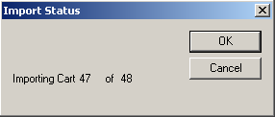

10) When the automatic import is complete the Import Report window will open.
The report that is generated will let you know how many files were imported and if there were any problems importing the files.
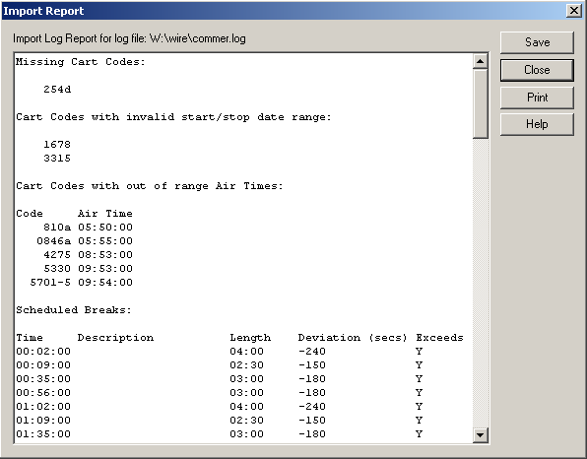

You can also print confirmation reports to quickly show how well the import took. PRINT THEM!!! There is no easier way to see how well the import took.

After the log has been imported it is a good idea to review the Automation Program and verify that the Scheduled Breaks are set up as you intended.

Then MOST IMPORTANTLY, SAVE and OVERWRITE the Automation Program.

Turnkey customers can have us dial in and make sure their automation programs are correctly formatted with scheduled breaks commands, that their traffic logs are formatted correctly, that our import settings are correct, and with general day to day steps to do what we discussed in this handout.

Configuring PlayOutReady

1) Click on Setup from the Main Menu, and then click on PlayOut Ready Setup.
The following window opens:
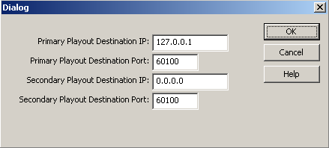

2) Enter the Primary Playout Destination IP address, which is the IP address of the computer that will be running PlayOutReady and displaying the video.
3) Enter the Primary Playout Destination Port if not using the default value of 60100. If this port number is modified, be sure to use the same value in the configuration of PlayOutReady.
4) Enter the Secondary Playout Destination IP address (not currently used).
5) Enter the Secondary Playout Destination Port (not currently used).
6) Click the OK button to save the settings.

The User *.ini File

[server]:\wire\users\[username]\[username].ini
This file holds configuration information for the user. The below section holds the settings affecting the PlayoutReady Master Control screen. This is not a complete list of all possible ini keys, but what is needed to configure PlayOutReady Master Control.

[PlayOutReady]
AutomationOnlyMode=yes
TVMode=yes
IP=127.0.0.1 The IP address of the PlayOutReady computer.
Port=60100 The port on the PlayOutReady computer.
SecondaryIP=0.0.0.0 This value is not used at this time.
SecondaryPort=60100 This value is not used at this time.

Preventing Accidental Stopping of the Running Playlists
The program is designed to be able to run 24/7 and automate the switching and playback of media files. To prevent the accidental modification or deletion of commands in the automation program, both the logic commands and the ability to change the state of the deck can be locked down.

Locking the Automation Deck
1) While in one of the 8 Automation Decks, click the Setup menu or strike Alt+S on the keyboard.
2) Choose Lock Deck or strike O on the keyboard. The Password window will open with the following text:
WARNING - DECK IS NOT LOCKED DOWN.
This controls whether or not the deck can be
started, stopped, loaded, or saved.
3) If a password will be assigned for this deck, click on the Use Password statement or strike Alt+U on the keyboard, and then enter a password into the Password field.
4) Click OK or strike Alt+O on the keyboard.
5) To unlock the deck, follow the same procedure as above, and uncheck the Lock Deck statement.

Each deck is locked independently, so the main running playlist(s) can be locked, while other decks can be left unlocked for editing.
Once the deck is locked, a warning window will be given if a user attempts to stop a running playlist, start an idle playlist, and load or save a playlist from that deck. Click the OK button to continue with the action, or the Cancel button to cancel the action. If a password has been set, the user will need to enter that before the action can be continued.

Locking the Logic Commands
There may be the need to lock the logic commands so that they cannot be changed. This will prevent users from accidentally deleting switcher and other logic commands, but will still allow users to modify/add/delete Play commands.
1) While in one of the 8 Automation Decks, click the View menu or strike Alt+V on the keyboard.
2) Choose Lock Logic or strike L on the keyboard. The Password window will open with the following text:
WARNING - LOGIC IS NOT LOCKED DOWN.
This controls whether or not the logic commands
in the playlist can be modified.
3) If a password will be assigned for this deck, click on the Use Password statement or strike Alt+U on the keyboard, and then enter a password into the Password field.
4) Click OK or strike Alt+O on the keyboard.
5) To unlock the logic, follow the same procedure as above, and uncheck the Lock Logic statement.

Each deck’s logic is locked independently, so the main running playlist(s) can be locked, while other decks can be left unlocked for editing.
Once the deck is locked, a warning window will be given if a user attempts to change a command other than Play commands from that deck. Click the OK button to continue with the action, or the Cancel button to cancel the action. If a password has been set, the user will need to enter that before the action can be continued.

Warning on Stop of Playlist and at Exit of Program
When the playlists are running, they should continue running or the media files will not continue to play. To prevent accidental stopping of the playlists, a warning message can be enabled to let users know that the playlist should not be stopped.
1) While in one of the 8 Automation Decks, click the Setup menu or strike Alt+S on the keyboard.
2) Choose Warn on Stop or strike W on the keyboard. The Password window will open with the following text:
STOPPING OF AUTIOMATION IS NOT LOCKED
You are about to warn people when
they try to stop this automation deck.
Do you want someone to have to enter
a password to stop this Automation deck?
3) If a password will be assigned for this deck, click on the Use Password statement or strike Alt+U on the keyboard, and then enter a password into the Password field.
4) Click OK or strike Alt+O on the keyboard.
5) To turn off the warning for the deck, follow the same procedure as above, and uncheck the Warn on Stop statement.

Each deck is set independently, so the main running playlist(s) can have the warning, while other decks can be left without the warning.
Once the warning is enabled, a warning window will be given if a user attempts to stop the running playlist in that deck Click the OK button to continue with the action, or the Cancel button to cancel the action. If a password has been set, the user will need to enter that before the action can be continued.

The same procedure is done to Warn on Exit, with the user checking/unchecking Warn on Exit from the Setup menu. The Warn on Exit applies to the program being closed, and is not set for each deck.

Printing the Playlists

WireReady32 can print the commands in a playlist from the PlayoutReady Master Control screen. The printout will include the Sequence #, the Command and the Parameters fields for each line of the playlist.
Note: If the PlayoutReady Master Control Decks are set to Hide Media Paths and Extensions and Hide Logic Parameters, these will not be printed. If you wish to print this information, uncheck these settings under the View menu before printing.

1. Open the playlist you wish to print in one of the decks (playlists will print from any of the 8 decks)
2. From the main menu, click on File or strike Alt+F on the keyboard.
3. Click on Print F5 or strike the F5 key.
The Select Print Range dialog box will open.
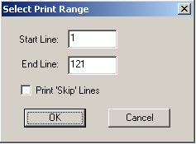
4. Enter the sequence number of the line that you wish to start printing on in the Start Line box.
5. Enter the sequence number of the line that you wish to stop printing on in the End Line box.
6. If you wish to only print the sequence lines that have commands on them, leave the Print “Skip” lines statement unchecked. Checking this statement will include the Skip lines in the printout and will make the printout use more pages.
7. Click the OK button or strike the Enter key.
Note: The playlists will not print in color.

Printing a List of Media Files from the MediaLog

It is now possible to print out a list of media files in the MediaLog folders. This output can be used to send a list of files to your traffic log provider.

1. Open the MediaLog folder you wish to print.

2. Click the F5 Print button or strike F5 on the keyboard.

3. The Print Options dialog box will open.
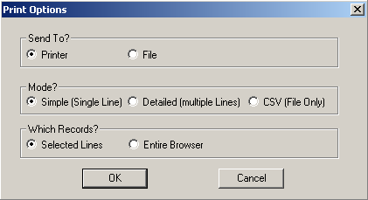

4. In the Send To? section, choose to send the information to the Printer or File.

5. In the Mode? section, choose the format of the file:
Simple (Single Line) will display the Filename, Description, Artist, Length, Saved By and Changed fields, with each media file’s information on one line.
Detailed (Multiple Lines) will display all of the fields for each media file, with each media file’s information taking 8 lines.
CSV (File Only) will display all the fields for each media file, with each field separated by a comma. This option will only send the info to a file, and will not print to the printer. If this option is chosen, File in the Send To? section will be marked.

6. In the Which Records? section, choose to print all the media files in the folder (Entire Browser), or only the ones that have been highlighted (Selected Lines).

7. Click OK.

HOW TO REACH WIREREADY

WireReady NSI
P.O. Box 714, Eudora, KS 66025
(800) 833-4459 USA & CANADA (785) 542-2173
E-MAIL: sales@wireready.com or support@wireready.com
www.wireready.com

